Zach Tzavelis

ME465 - Sound and Space

02/13/2020

HW2: RMS Averaging Effect on Power Spectral Density

**Exercise 1.3.1**

The task was to analyze a 16 second signal (fs: 1024 Hz) with a frequency of 120 Hz hidden in noise (Figure 1). The task was focused on highlighting the impact of root mean squared (RMS) averaging of the power spectral density (Gxx) function. To compute the RMS of Gxx, the time domain signal was sliced into 16 one-second segments and Gxx was computed on each of them, before averaging all of them together. Figure 2 depicts the difference between the spectral density function of the entire signal verses the RMS averaged version (Gxx_a).

Figure 1: 120 Hz Signal Hidden in Noise

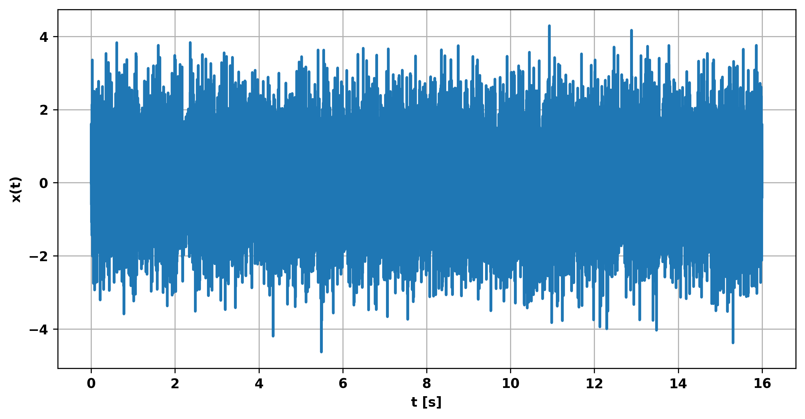

Figure 2: Power Spectral Density with and without RMS Averaging

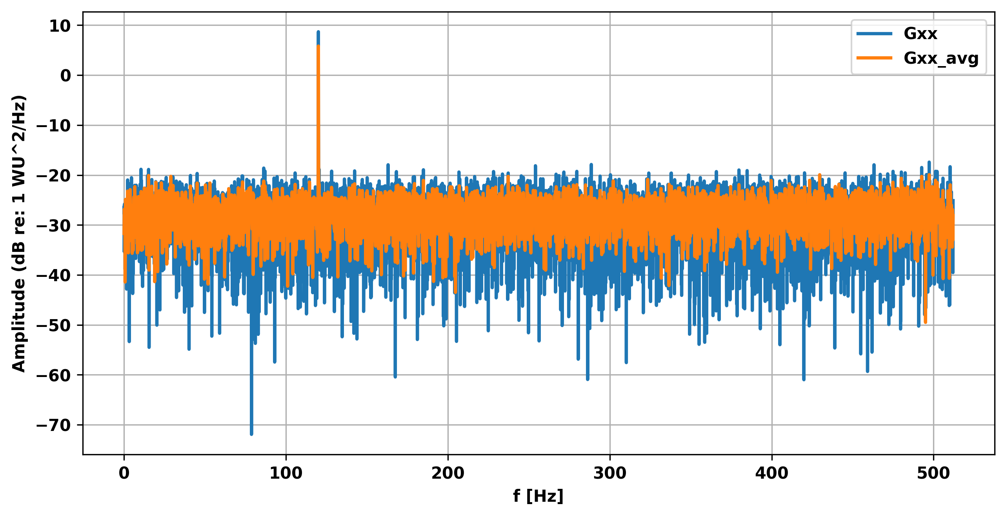

The first notable result of RMS averaging Gxx is the reduced variability across the frequency spectrum — the amplitude of the signal at 120 Hz also decreases; the average amplitude value stays about the same, however. The reduction in amplitude across the frequency spectrum makes sense since the magnitude of Gxx_a is the simple average of 16 ‘smaller’ Gxx signals; such an average would get rid of some of the variability in the amplitude of the 16 Gxxs.

**Concluding Remarks**

RMS averaging of Gxx seems like a good solution for getting rid of some amplitude noise, but only when that noise is relatively small compared to the signal. Increasing the amount of noise could bury the original signal, and performing an RMS on Gxx could result in missing the important signal at 120 Hz (in this case). It may be more useful to perform something like linear averaging of X since one can then take advantage of phase and magnitude information instead of just the magnitude — like in Gxx RMS averaging performed in this excercise.